## Setting NMEA in the sensorlist

Since revision 3616 it is also possible to set the NMEA interfaces directly in the sensorlist. This needs an extra explanation cause it works a slightly bit different.

We will focus on the columns that are important. The other columns will all practically work the same as described earlier.

As example we will take a Voith NMEA interface. As you can see in the following figure, the standard columns will be the same as you already learned.

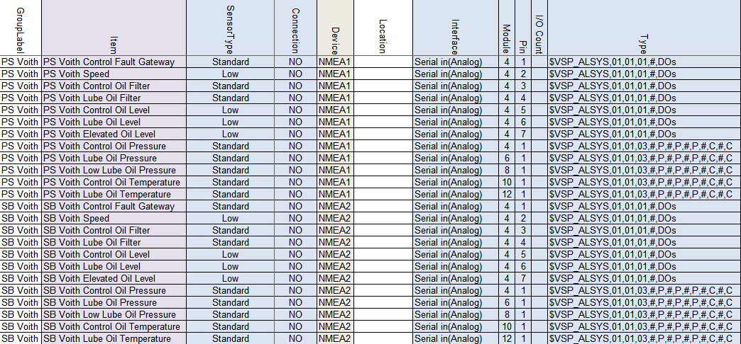

Figure 14‑3: NMEA sensorlist example

Grouplabel, Item, Sensor Type, Connection and Device are the same as described earlier. The alternative columns we’ll describe here.

### Interface

With NMEA you can choose between Serial in(Analog) and Serial out(Analog), depending if you want to receive or send.

### Module

As you will see in the column “type” you set the standard NMEA sentence there. All values are defined between comma’s in that sentence. To let NavVision know which value you are looking at, you will set the comma after which the value is available in the NMEA sentence. So if you need the value after the 4th comma in the NMEA sentence, you will put a 4 here.

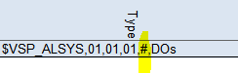

Figure 14‑4: NMEA example 1

*:the “#” sign is just to make it more visible and is not mandatory. You can leave the string without these.*

### Pin

To see which character behind the specific comma you need, under Pin you define the character number. In our example we have on that spot the digital values for the VOITH. So there are 7 zero’s or ones there, each representing one digital input. In our example we define all these values in the first seven rows.

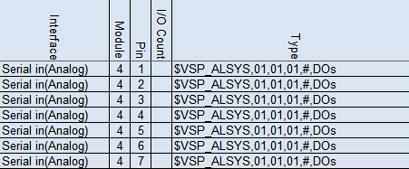

Figure 14‑5: NMEA example 2

*:Make sure that the count column is set to “1” cause you only want to read one character at the time.*

### Type

The Type column is the specific NMEA sentence that you are expecting. Lets analyse a sentence.

$VSP_ALSYS = talker ID and Sentence Identifier

,01 = digital value

,03 = analog value

,# = wildcard

Or another example:

$GPRMC,220516,A,5133.82,N,00042.24,W,173.8,231.8,130694,004.2,W*70

$GPRMC = talker ID and Sentence Identifier

,220516 = time stamp

,A = valid or ”V” invalid

Etc.

If you know the characters that are needed, you can fill it in.



The “P” and “C” represent Pressure and Celcius.

*: make sure that if you have an analog value, you set the Count column to the right amount of characters to read. Default is 16, which should be enough in most cases.*

### Count

At the count column you specify how many characters you will read at maximum on that specific location. So for digital values that will be 1. For analog values you will have to look at the original NMEA sentence. It can be that you need to read 4 characters max or 6. Whatever max number of characters you find for that field, you will define here at “count”.

*: The column “Data Type” is necessary if you send NMEA data. You will set the right parameter (see chapter 11.3.23).*

### Count

At the count column you specify how many characters you will read at maximum on that specific location. So for digital values that will be 1. For analog values you will have to look at the original NMEA sentence. It can be that you need to read 4 characters max or 6. Whatever max number of characters you find for that field, you will define here at “count”.

### Non-standard NMEA strings

It is possible to make your own NMEA string. Let’s say that you need to send some values or digital data to a VDR. It is possible to make your own string for that.

First make sure that you make a unique Talker-ID and Sentence identifier. If it is non-standard NMEA it has to start with a “P” and since we are making this for FT we will make the first ID “PFT”. If you want to distinguish different kind of values that you send, or if you have more than 79 characters, you can use the rest of the sentence identifier to make that distinction.

Assume we are going to send watertight door information to the VDR. The “Talker-ID, sentence identifier” could look like the following:

$PFT_WTD

If you know how much values you need, you can fill in the commas with or without the hashtag. So for example:

$PFT_WTD,#,#,#,#,#,#

Or

$PFT_WTD,,,,,,

For the rest it works the same. In the column “Module” you define after which comma you want to read and in the column “Pin” you define which character you want to read.

In the sensorlist it will looks as follows:

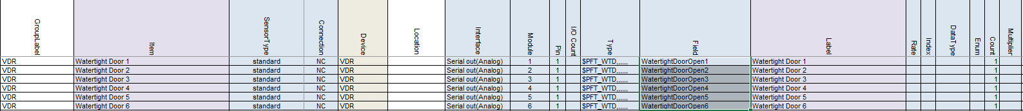

Figure 14‑6: Non-standard NMEA

*: If you want to send an Analog value, make sure that you set the “Data Type” on Float*